The code below:
- Validates and converts the measurements into hourly observations.
- Creates historical and calendar predictors.
- Defines next-hour NO₂ as the target.
- Splits the data chronologically.
- Fits missing-value imputation and scaling on training data only.
- Exports model-ready training, validation, and test datasets.
Fitting preprocessing only on training data prevents validation and test information from leaking into model development.

1. Forecasting task and assumptions
Item | Configuration
Target | Next-hour Queen Street NO₂
Predictors | Available NO₂ history, RH, temperature, wind speed, wind-direction components, calendar features
Training period | First 60% of the hourly timeline
Validation period | Next 20%
Test period | Final 20%
Missing predictor values | Training-median imputation, with missingness indicators
Missing target values | Excluded; never imputed
Scaling | StandardScaler fitted on training data
Outliers | Retained pending source verification
The hourly aggregation assumes the original timestamps identify observation instants. It groups observations into clock-hour intervals and labels each interval by its end. Confirm this interpretation and the source timezone before final research modelling.

2. Python Code
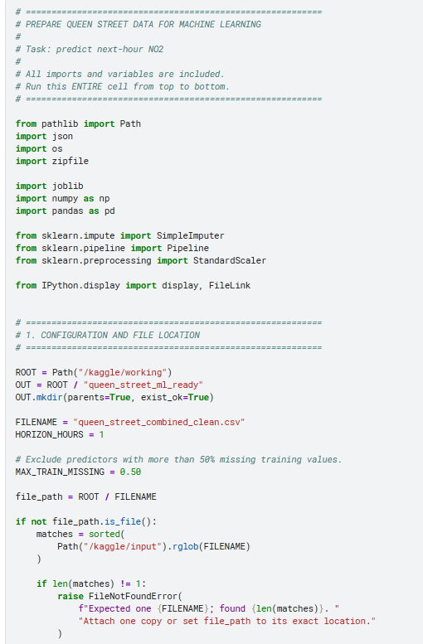

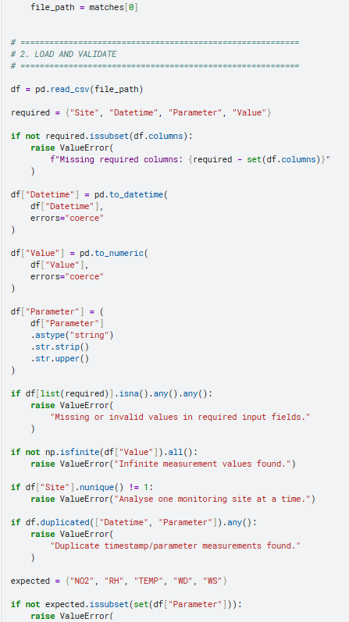

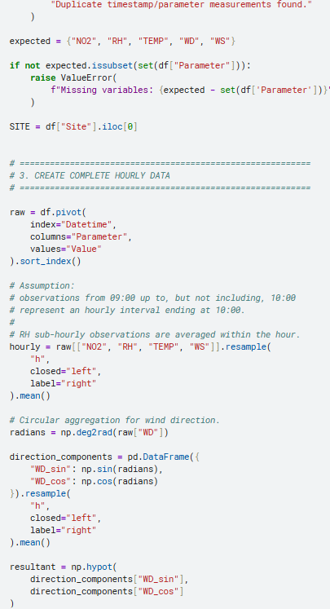

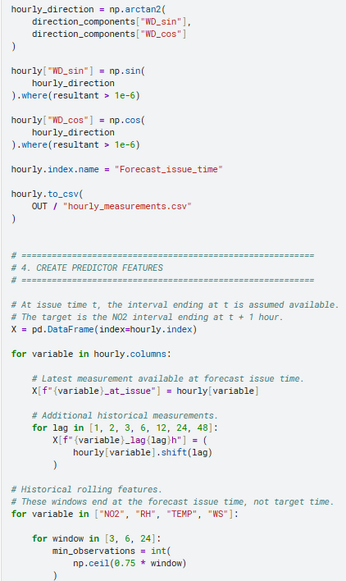

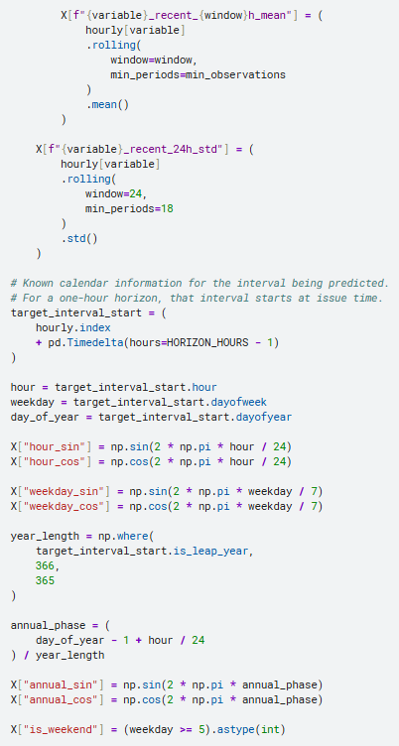

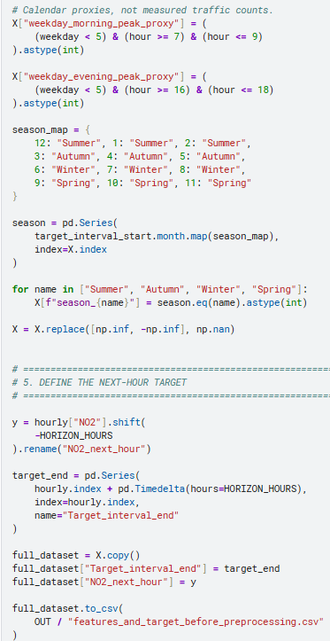

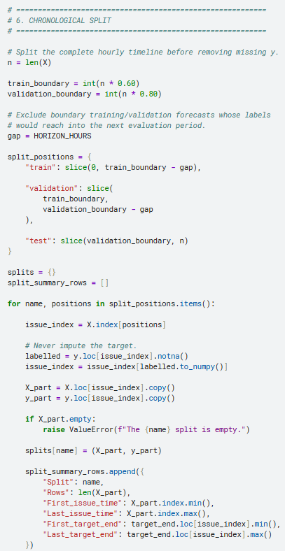

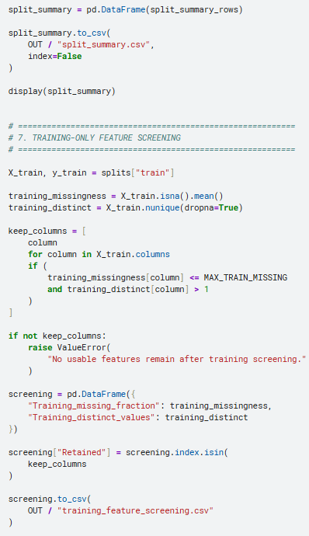

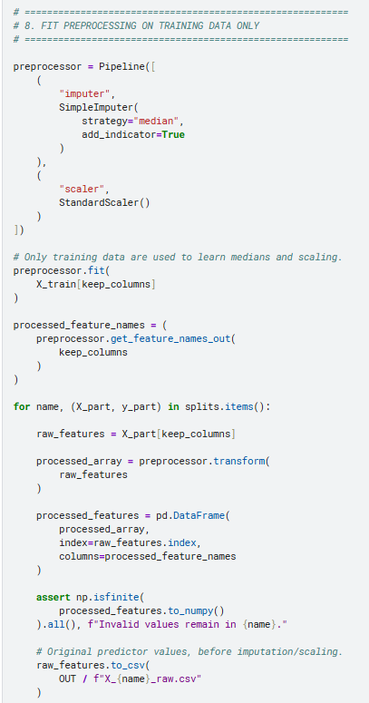

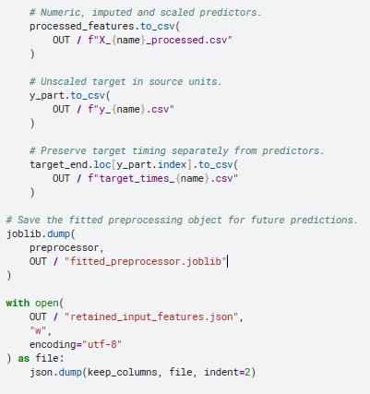

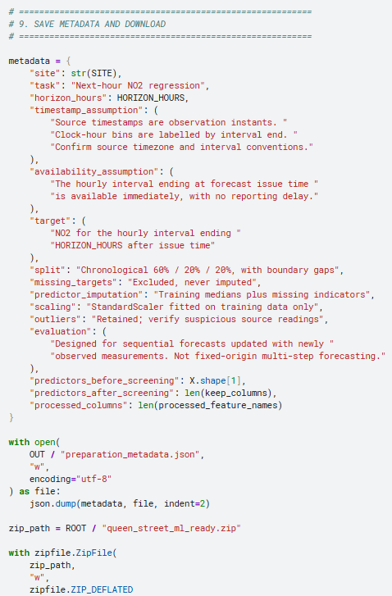

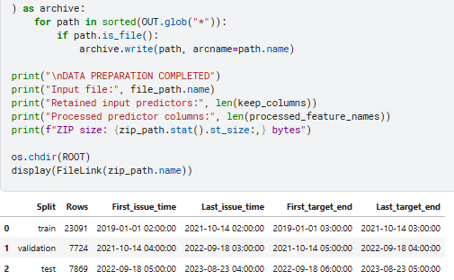

3. How the preparation works

A. Hourly observations
The code converts the original long-format measurements into one row per hour.
RH’s sub-hourly readings are averaged within clock-hour bins. Wind direction is converted into circular components rather than averaged as ordinary degrees.
Absent hours remain in the timeline. This ensures that a 24-row shift represents 24 hours rather than 24 available observations separated by unknown gaps.

B. Predictors and target
For a forecast issued at time ttt:
Xt=information available at or before tX_t=\text{information available at or before }tXt​=information available at or before t
yt=NO2 for the interval ending at t+1 houry_t=\mathrm{NO_2}\text{ for the interval ending at }t+1\text{ hour}yt​=NO2​ for the interval ending at t+1 hour
For example:
Forecast issue: 10:00
Latest observed hour: 09:00–10:00
Predicted hour: 10:00–11:00
Target interval end: 11:00

The latest NO₂ measurement is allowed as a predictor because it belongs to the completed hour—not the future hour being predicted.
This assumes no measurement-reporting delay. If values become available later, the predictors must be shifted further back.

C. Missing values
The code treats predictors and targets differently:
- Missing predictors: imputed using training-set medians.
- Missing targets: excluded.
- Missingness indicators: added where the training data contain missing predictor values.
It does not replace missing pollution measurements with zero.

D. Chronological splitting
Training uses earlier observations; validation and test use later periods.
Small boundary gaps prevent the last training labels from reaching into the next evaluation period.
The test dataset should remain untouched while choosing models and settings. Preprocessing and feature-selection decisions must not be fitted using test observations.

E. Scaling
StandardScaler transforms predictors using:
z=x−μtrainingσtrainingz=\frac{x-\mu_{\text{training}}} {\sigma_{\text{training}}}z=σtraining​x−μtraining​​
The training means and standard deviations are reused for validation, test, and future predictions. Targets remain in their original units.
The processed files are a general numeric starting point. Keep the raw predictor exports as well, so you can build model-specific pipelines without losing the original feature values.

F. Feature screening
Only training-period information is used to exclude predictors that:
- Have more than 50% missing values.
- Have no variation.
This is basic data-readiness screening, not a final determination of predictive importance. Later feature selection should also be performed within training data or training folds.scikit-learn

4. Files to use for modelling
File | Purpose
X_train_processed.csv | Prepared training predictors
y_train.csv | Training NO₂ targets
X_validation_processed.csv | Prepared validation predictors
y_validation.csv | Validation targets
X_test_processed.csv | Prepared test predictors
y_test.csv | Final test targets
X_*_raw.csv | Predictors before imputation and scaling
target_times_*.csv | Actual target interval-end timestamps
fitted_preprocessor.joblib | Reusable fitted imputer and scaler
training_feature_screening.csv | Features retained or excluded
preparation_metadata.json | Assumptions and configuration
When loading the CSVs for modelling, keep the timestamp as the index rather than treating it as an input predictor:

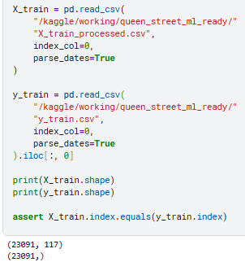

The prepared data are suitable for sequential one-hour-ahead evaluation: later test forecasts may use measurements observed earlier in the test period. They are not a fixed-origin forecast of the entire test period using only information available at its beginning.

TARGET O3, concentration and the predictors as NOx, meteorological measurements, traffic proxies, and temporal features.

I have prepared a provisional modelling dataset and chronological splits from your uploaded files. Patumahoe is necessary because it supplies both O₃ and NOx; Queen Street supplies the available meteorological measurements. This is therefore a cross-site modelling design, not a model of measured Queen Street ozone.

1. Define the target

Target variable
python
target = "Patumahoe O3 concentration for the next hour"
The forecasting task is:
O3^PAT, t+1=f(NOxPAT, ≤t,MeteorologyQUS, ≤t,TrafficProxies,TemporalFeatures)\widehat{\mathrm{O_3}}_{\mathrm{PAT},\,t+1} = f\left( \mathrm{NOx}_{\mathrm{PAT},\,\leq t}, \mathrm{Meteorology}_{\mathrm{QUS},\,\leq t}, \mathrm{TrafficProxies}, \mathrm{TemporalFeatures} \right)O3​​PAT,t+1​=f(NOxPAT,≤t​,MeteorologyQUS,≤t​,TrafficProxies,TemporalFeatures)
In practical terms:
Item | Meaning
Forecast issue time | Time t
Latest measurements allowed | Completed hourly intervals ending at or before ttt
Prediction | O₃ for the next hourly interval
Target interval end | t+1 hour
Target location | Patumahoe
Historical O₃ is not included as a predictor in this specification, matching your requested predictor groups. It remains available as the target and can later support a separate persistence benchmark.

Important interpretation
The target’s numerical units remain those in the source CSV. Confirm the original concentration units before reporting model errors in physical units or comparing predictions with air-quality guidelines.patumahoe_combined_clean.csv

2. Define the predictors

A. NOx predictors: Patumahoe
Examples:
text
PAT_NOX_at_issue
PAT_NOX_lag1h
PAT_NOX_lag3h
PAT_NOX_lag6h
PAT_NOX_lag24h

PAT_NOX_recent_3h_mean
PAT_NOX_recent_6h_mean
PAT_NOX_recent_24h_mean
PAT_NOX_at_issue is the most recent completed hourly NOx measurement. A lag of 24 hours represents an additional 24-hour shift from the forecast issue time.
NOx is taken from Patumahoe, rather than substituting Queen Street NO₂ for NOx. These are different measurements.patumahoe_combined_clean.csv+1

B. Meteorological predictors: Queen Street
The prepared features use:
Measurement | Feature representation
Temperature | Latest available value, historical lags, rolling means
Relative humidity | Latest available value, historical lags, rolling means
Wind speed | Latest available value, historical lags, rolling means
Wind direction | Sine/cosine components and their historical lags
Examples:
text
QUS_TEMP_at_issue
QUS_RH_lag3h
QUS_WS_recent_6h_mean
QUS_WD_sin_at_issue
QUS_WD_cos_lag24h
Wind direction is represented circularly so that directions near 0° and 360° are treated as close.
Solar radiation is not included because neither cleaned file provides it. No synthetic radiation measurements have been invented.patumahoe_combined_clean.csv+1

C. Traffic proxies
The files do not contain measured traffic counts or an emissions inventory. The prepared dataset therefore uses explicitly labelled calendar proxies:
text
weekday_morning_peak_proxy
weekday_evening_peak_proxy
weekday_business_hours_proxy
Their definitions are:
Proxy | Definition
Morning peak | Monday–Friday, 07:00–09:59
Evening peak | Monday–Friday, 16:00–18:59
Business hours | Monday–Friday, 09:00–17:59
These are assumptions about activity periods—not observed traffic or emissions. They should be described as calendar-based traffic proxies in your methodology.

D. Temporal features
The prepared predictors include:
text
hour_sin
hour_cos
weekday_sin
weekday_cos
month_sin
month_cos
day_of_month
is_weekend
season_Autumn
season_Winter
season_Spring
Summer is the reference season.
The calendar features describe the hour being forecast and are known in advance.

3. How the two files were combined
The preparation:
- Validates each file separately.
- Aggregates measurements into hourly intervals.
- Uses circular aggregation for wind direction.
- Keeps missing hours in the timeline.
- Selects the common monitoring span for O₃, NOx, and the weather variables.
- Creates historical predictors without using future measurements.
- Removes the initial 24-hour lag warm-up.
- Splits chronologically before excluding missing targets.
RH starts in December 2020, so the combined design does not use the earlier years as though meteorological coverage were complete.queen_street_combined_clean.csv

Timestamp assumption requiring verification
The preparation assumes:
- Both sources use compatible clock conventions.
- Original timestamps identify observation instants.
- An hourly interval is available immediately when it ends.
Hourly bins are labelled by their end time. For example, source observations during 09:00–09:59 contribute to the interval ending at 10:00.
These are explicit assumptions, not facts established by the cleaned CSVs. The combined dataset is provisional until the source timezone, interval definitions, and reporting delays are confirmed.

4. Chronological training, validation, and testing datasets
I used:
text
Training: first 60% of the eligible hourly timeline
Validation: next 20%
Testing: final 20%
A one-hour boundary buffer separates training labels from the next evaluation period. Missing O₃ targets are excluded after splitting; targets are never imputed.
The actual retained splits are:
Dataset | Labelled rows | First forecast issue | Last forecast issue
Training | 12,841 | 2 December 2020, 01:00 | 21 July 2022, 11:00
Validation | 4,720 | 21 July 2022, 13:00 | 5 February 2023, 07:00
Testing | 4,718 | 5 February 2023, 11:00 | 23 August 2023, 04:00
Calculated from the two uploaded files under the hourly-bin assumptions above. Each target interval ends one hour after its forecast issue time.patumahoe_combined_clean.csv+1
The final row counts are not exactly 60/20/20 because the percentages apply to the hourly timeline before removing missing targets and boundary rows.

Purpose of each split
- Training: fit preprocessing and model parameters.
- Validation: choose model settings and compare feature configurations.
- Testing: estimate final performance after development decisions are complete.
Do not randomly shuffle these observations or fit preprocessing on the complete dataset. Learned preprocessing must use training observations only.scikit-learn

5. Missing values and scaling
The preparation produced:
- 56 retained input predictors.
- 98 processed columns after adding training-derived missingness indicators.patumahoe_combined_clean.csv+1
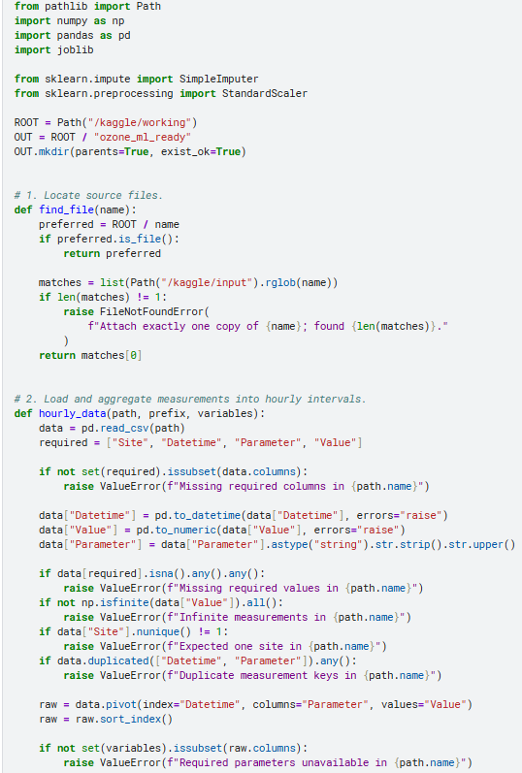
The preprocessing is:

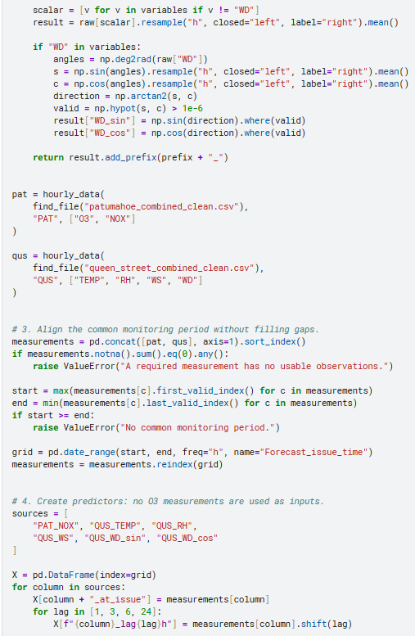

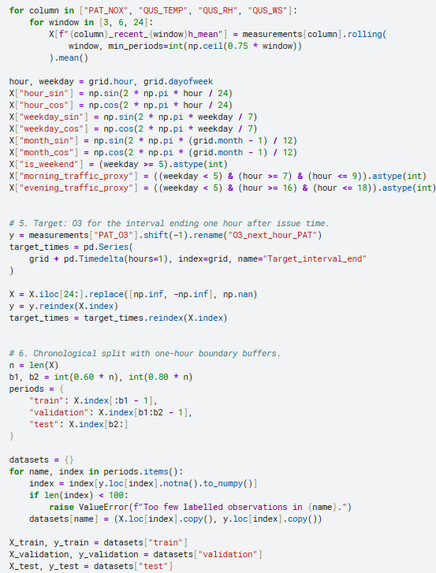

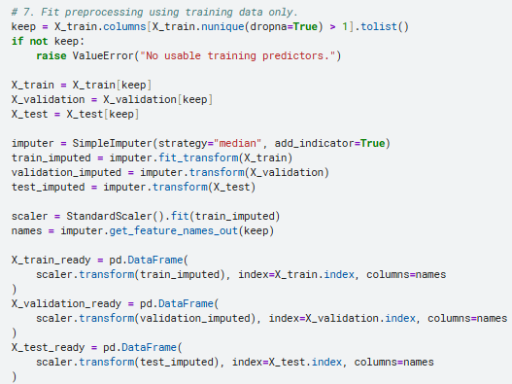

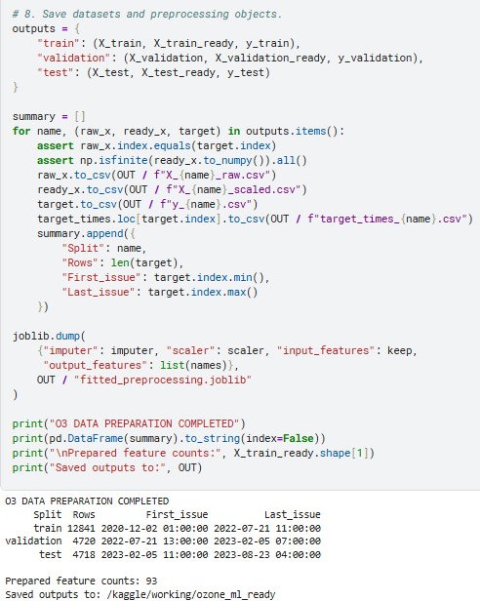

O3 DATA PREPARATION COMPLETED
Then use:
Purpose | Predictors | Target
Training | X_train_ready | y_train
Validation | X_validation_ready | y_validation
Testing | X_test_ready | y_test
This shorter version preserves the requested predictor groups but omits some optional calendar descriptors from the longer script. It assumes matching source clocks, end-labelled hourly intervals, and no reporting delay. The meteorology remains Queen Street data, while O₃ and NOx are from Patumahoe; verify those timing assumptions before final modelling.

Research wording you can use
The prediction target was hourly ozone concentration at Patumahoe, forecast one hour ahead. Predictors comprised historical Patumahoe NOx concentrations, historical Queen Street meteorological measurements, calendar-based traffic proxies, and temporal features. Site identifiers were retained in predictor names to distinguish local pollutant information from cross-site meteorological information. The dataset was partitioned chronologically into training, validation, and testing periods. Missing target observations were excluded, while predictor imputation and scaling were fitted exclusively on the training dataset.
Add that the cross-site timestamp conventions require verification and that this design does not establish Queen Street weather as representative of conditions at Patumahoe.

TRAIN SUPERVISED MACHINE LEARNING MODELS

1. Models included
Model | Purpose | Hyperparameter tuning
Mean baseline | Predicts the training-period mean O₃ | None
Ridge linear baseline | Establishes a regularised linear benchmark | Regularisation strength
Random forest | Models nonlinear relationships and interactions | Tree count, depth, leaf size, feature sampling
XGBoost | Gradient-boosted regression model | Tree count, depth, learning rate, sampling, regularisation
LightGBM fallback | Used if XGBoost is unavailable but LightGBM is installed | Tree count, leaves, depth, learning rate, regularisation
The notebook uses XGBoost’s histogram tree method for its boosting implementation. XGBoost documents hist as a histogram-based approximation intended to accelerate tree construction.xgboost+1
Only one boosting library is used per run: XGBoost is preferred; LightGBM is the fallback.

2. Target and predictors
The notebook retains your requested specification:

Target
yt=Patumahoe O₃ for the hourly interval ending at t+1y_t=\text{Patumahoe O₃ for the hourly interval ending at }t+1yt​=Patumahoe O₃ for the hourly interval ending at t+1

Predictors available at forecast issue time ttt
- Patumahoe NOx.
- Queen Street temperature, RH, wind speed, and wind-direction components.
- Historical lags and rolling averages of those measurements.
- Hourly, weekly, monthly, and seasonal features.
- Calendar-based morning/evening traffic-period proxies.
O₃ history is not included in the supervised-model inputs. A separate persistence benchmark uses the latest observed O₃ only to assess whether the trained models improve on a simple forecasting alternative.
This remains a provisional cross-site design. Matching clock conventions, measurement intervals, and reporting delays must be verified before interpreting the results as operational forecast performance.

3. Time-aware cross-validation
The workflow has two levels of chronological evaluation.

Outer holdout datasets
text
Earlier observations Later observations
─────────────────────────────────────────────────────────────────────────
Training: 60% Validation: 20% Testing: 20%
The proportions apply to the hourly timeline before missing targets are removed.

Expanding-window cross-validation inside training
text
Fold 1: [Training] → [CV validation]

Fold 2: [Expanded training] → [CV validation]

Fold 3: [Further expanded training] → [CV validation]
The notebook constructs folds on the complete hourly calendar, then maps them to available target observations. Consequently, missing target hours do not collapse the time axis.
A one-hour gap separates each fold’s training and validation periods.

Preprocessing happens inside each fold
Each candidate model is wrapped in a pipeline:
text
Raw predictors
↓
Training-fold median imputation
↓
Missing-value indicators
↓
Scaling for the Ridge model
↓
Regression model
Imputation and scaling are learned separately within each training fold—not once on the complete dataset. This avoids preprocessing leakage into cross-validatioNS.

4. Hyperparameter tuning
The notebook uses RandomizedSearchCV with:
python
N_SPLITS = 3
N_ITER = 6
This means six sampled configurations per tuned model, evaluated using three expanding-window folds.
The settings are deliberately modest for an initial Kaggle run. Increase them before final evaluation if computational resources permit.

Random forest search
text
n_estimators: 100, 200
max_depth: 8, 16, unrestricted
min_samples_leaf: 2, 5, 10
max_features: 0.5, 0.8, 1.0

XGBoost search
text
n_estimators: 150, 300, 450
max_depth: 2, 3, 5
learning_rate: 0.03, 0.05, 0.10
subsample: 0.7, 1.0
colsample_bytree: 0.7, 1.0
min_child_weight: 1, 5, 10
reg_lambda: 1, 5, 10
Hyperparameters are chosen by the lowest average cross-validation RMSE. MAE and R² are recorded as additional diagnostics.
The test dataset is not used for tuning or early stopping.

5. Predictions and evaluation metrics
Every model generates predictions for the chronological validation dataset and, after its fixed configuration is refitted on training plus validation data, the test dataset.

MAE
MAE=1n∑i=1n∣yi−y^i∣\mathrm{MAE} = \frac{1}{n}\sum_{i=1}^{n}|y_i-\hat{y}_i|MAE=n1​i=1∑n​∣yi​−y^​i​∣
MAE expresses the average absolute prediction error in the target’s concentration units.

RMSE
RMSE=1n∑i=1n(yi−y^i)2\mathrm{RMSE} = \sqrt{ \frac{1}{n}\sum_{i=1}^{n}(y_i-\hat{y}_i)^2 }RMSE=n1​i=1∑n​(yi​−y^​i​)2​
RMSE gives greater weight to large errors.

R²
R2=1−∑i(yi−y^i)2∑i(yi−yˉ)2R^2 = 1- \frac{\sum_i(y_i-\hat{y}_i)^2} {\sum_i(y_i-\bar{y})^2}R2=1−∑i​(yi​−yˉ​)2∑i​(yi​−y^​i​)2​
R² compares prediction errors with variation around the evaluation dataset’s mean. It can be negative.
The resulting comparison tables have this structure:
Model | MAE | RMSE | R²
Mean baseline | Calculated during execution | Calculated during execution | Calculated during execution
Ridge baseline | Calculated during execution | Calculated during execution | Calculated during execution
Random forest | Calculated during execution | Calculated during execution | Calculated during execution
XGBoost/LightGBM | Calculated during execution | Calculated during execution | Calculated during execution
No numerical results are assumed in advance.

6. Best-model selection
The selection rule is fixed before examining test predictions:
Select the model with the lowest validation RMSE, using validation MAE as a tie-breaker.
The notebook then:
- Records the selected model.
- Freezes the tuned configurations.
- Refits each configuration on training plus validation data.
- Reports test performance for every model.
- Saves the preselected model separately.
Do not replace the selected model merely because another model obtains the lowest test RMSE. Doing so would turn the test dataset into another model-selection dataset.
The persistence comparison is also important: if the selected model does not improve on the previous observed O₃, report that limitation rather than claiming that the more complex model provides better forecasts.

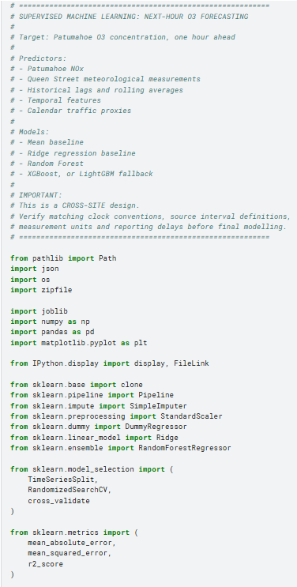

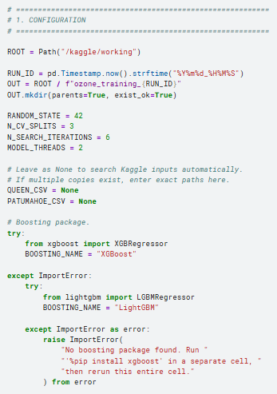

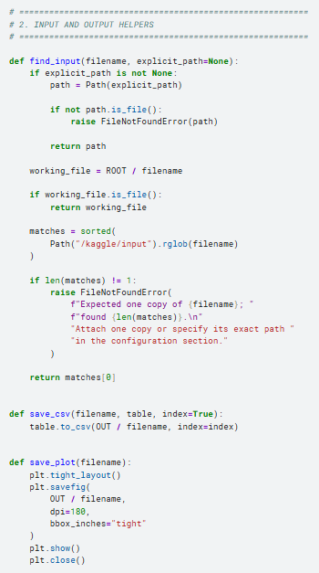

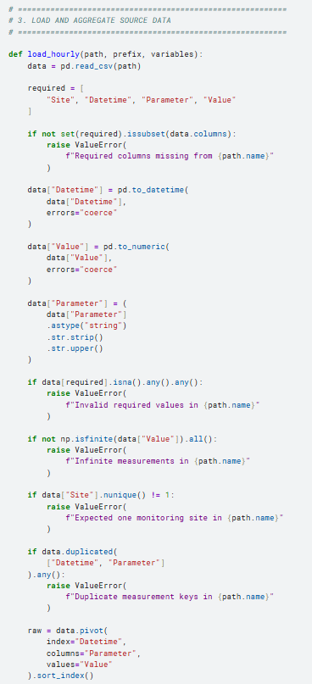

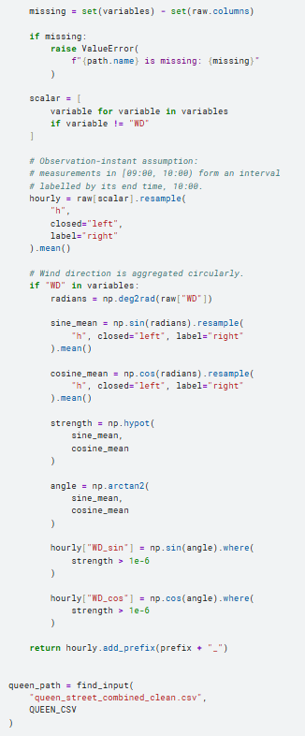

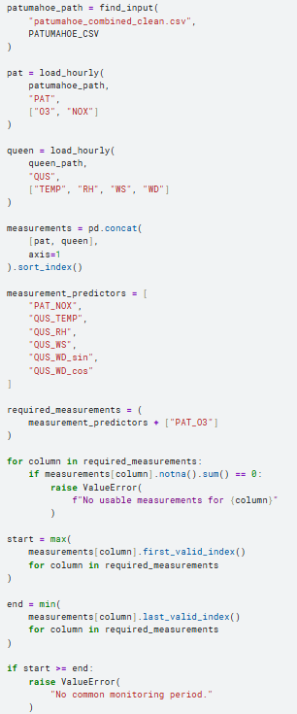

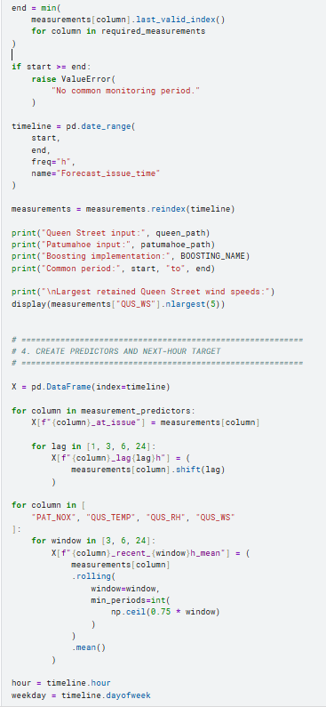

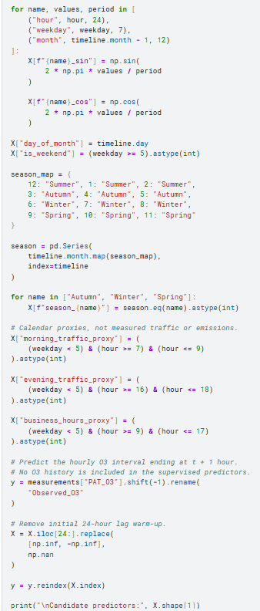

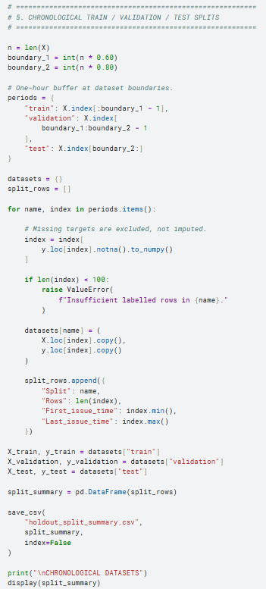

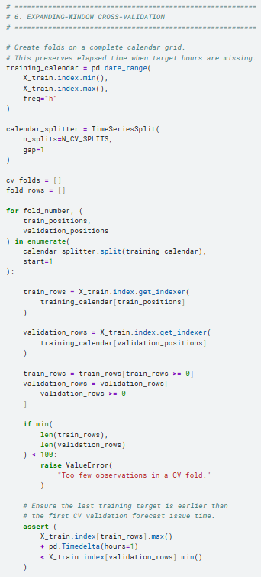

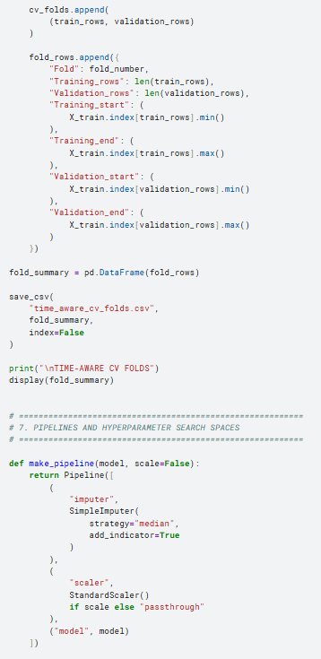

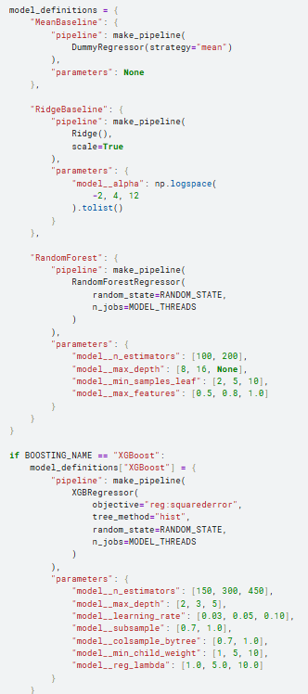

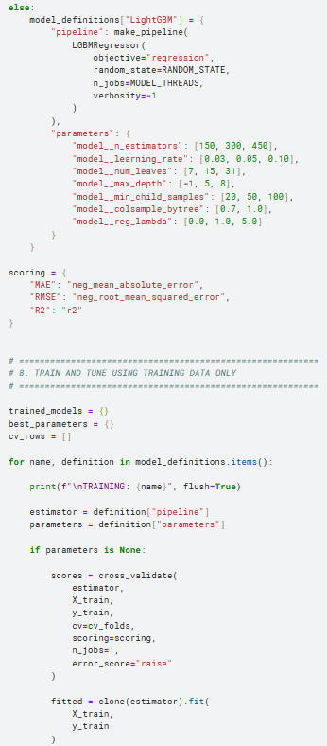

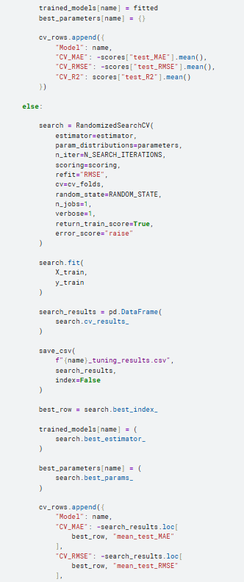

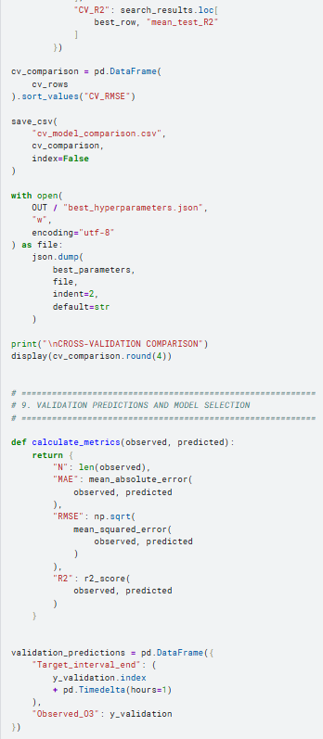

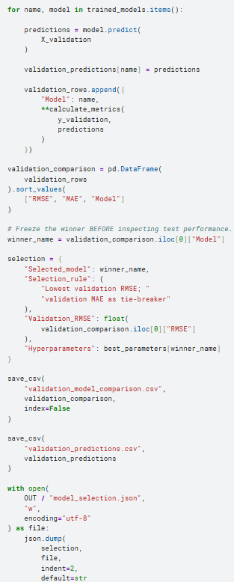

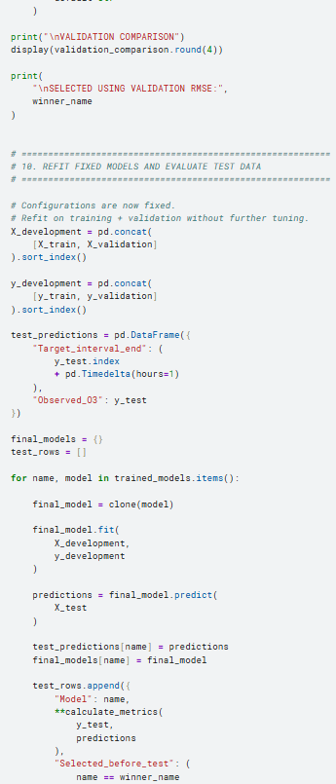

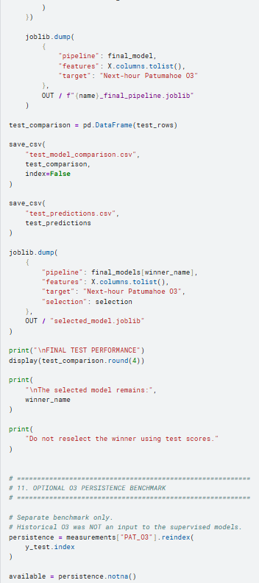

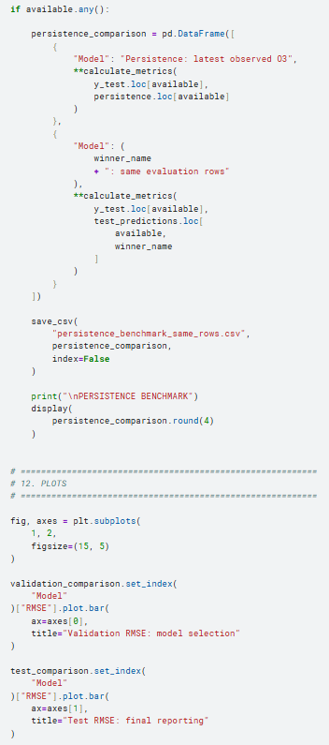

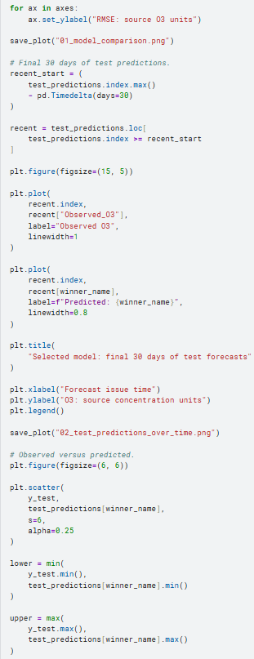

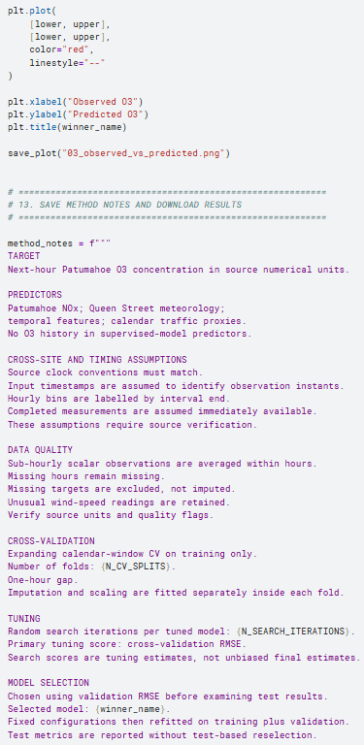

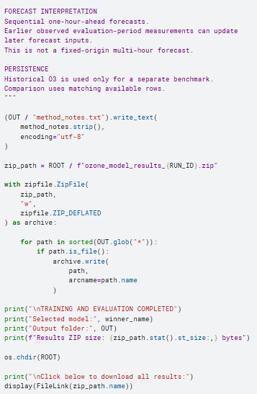

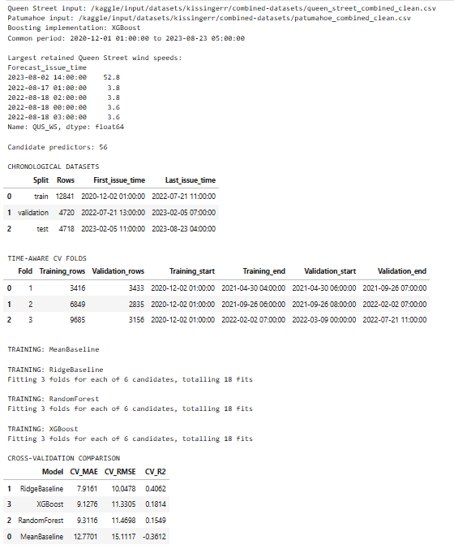

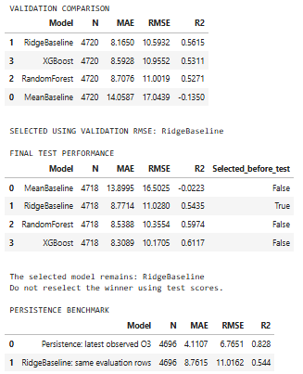

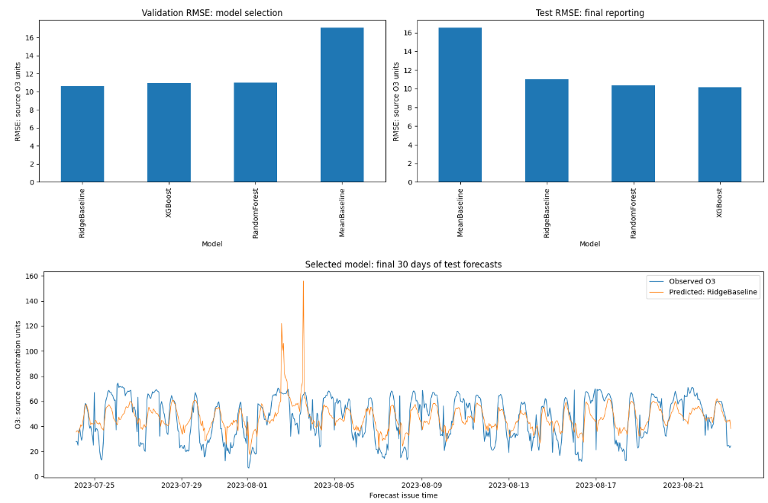

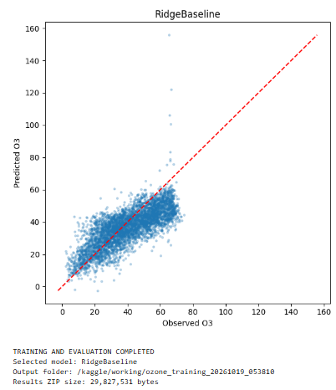

7. Files generated by the notebook
Output | Contents
cv_model_comparison.csv | Cross-validation MAE, RMSE, and R²
time_aware_cv_folds.csv | Actual dates and row counts for each fold
*_tuning_results.csv | Candidate hyperparameters and CV scores
best_hyperparameters.json | Best parameters for each model
validation_predictions.csv | Observed and predicted validation O₃
validation_model_comparison.csv | Validation performance
model_selection.json | Winner selected before test evaluation
test_predictions.csv | Observed and predicted test O₃
test_model_comparison.csv | Final test performance
persistence_benchmark_same_rows.csv | Fair comparison with previous-O₃ persistence
selected_model.joblib | Selected fitted preprocessing-and-model pipeline
*_final_pipeline.joblib | Each fitted model pipeline
PNG figures | Model comparison, test time series, observed versus predicted
Results ZIP | All generated outputs

